Test 1 - Static High Performance Mode

**Static High Performance Mode**—Processors will run at maximum power/performance at all times, regardless of the OS power management policy.

CPUZ Bench

|  |  |
| --- | --- |
| First execution | Second execution |

SQL Server test

Test 1 – Small table

USE tempdb

GO

IF OBJECT_ID('TabTest1') IS NOT NULL

DROP TABLE TabTest1;

CREATE TABLE TabTest1(Col1 CHAR(500));

INSERT INTO TabTest1

SELECT TOP 50000

CONVERT(CHAR(100), 'Test, fixed data to be used on test') AS Col1

FROM master.dbo.sysobjects A,

master.dbo.sysobjects B,

master.dbo.sysobjects C,

master.dbo.sysobjects D

OPTION (MAXDOP 1);

UPDATE STATISTICS TabTest1 WITH ROWCOUNT = 1000000, PAGECOUNT = 100000

GO

-- Quick scan to make sure all pages are in cache

SET STATISTICS IO ON

SELECT COUNT(*) FROM TabTest1

SET STATISTICS IO OFF

GO

SET STATISTICS IO, TIME ON

GO

DECLARE @Col1 CHAR(100)

SELECT TOP 100 @Col1 = Col1 FROM TabTest1

ORDER BY Col1

OPTION (MAXDOP 1)

SELECT TOP 100 @Col1 = Col1 FROM TabTest1

ORDER BY Col1

OPTION (MAXDOP 8)

SELECT TOP 100 @Col1 = Col1 FROM TabTest1

ORDER BY Col1

OPTION (MAXDOP 16)

GO

SET STATISTICS IO, TIME OFF

GO

/*

SQL Server parse and compile time:

CPU time = 0 ms, elapsed time = 0 ms.

Table 'TabTest1'. Scan count 1, logical reads 3334, physical reads 0, read-ahead reads 0, lob logical reads 0, lob physical reads 0, lob read-ahead reads 0.

(1 row affected)

SQL Server Execution Times:

CPU time = 390 ms, elapsed time = 393 ms.

Table 'TabTest1'. Scan count 9, logical reads 3334, physical reads 0, read-ahead reads 0, lob logical reads 0, lob physical reads 0, lob read-ahead reads 0.

(1 row affected)

SQL Server Execution Times:

CPU time = 532 ms, elapsed time = 125 ms.

Table 'TabTest1'. Scan count 17, logical reads 3334, physical reads 0, read-ahead reads 0, lob logical reads 0, lob physical reads 0, lob read-ahead reads 0.

(1 row affected)

SQL Server Execution Times:

CPU time = 625 ms, elapsed time = 90 ms.

SQL Server parse and compile time:

CPU time = 0 ms, elapsed time = 0 ms.

Completion time: 2020-09-09T01:51:39.2606145-03:00

*/

SQL Query Stress tests:

|  |  |
| --- | --- |
|  |  |
|  |  |

Profiler:

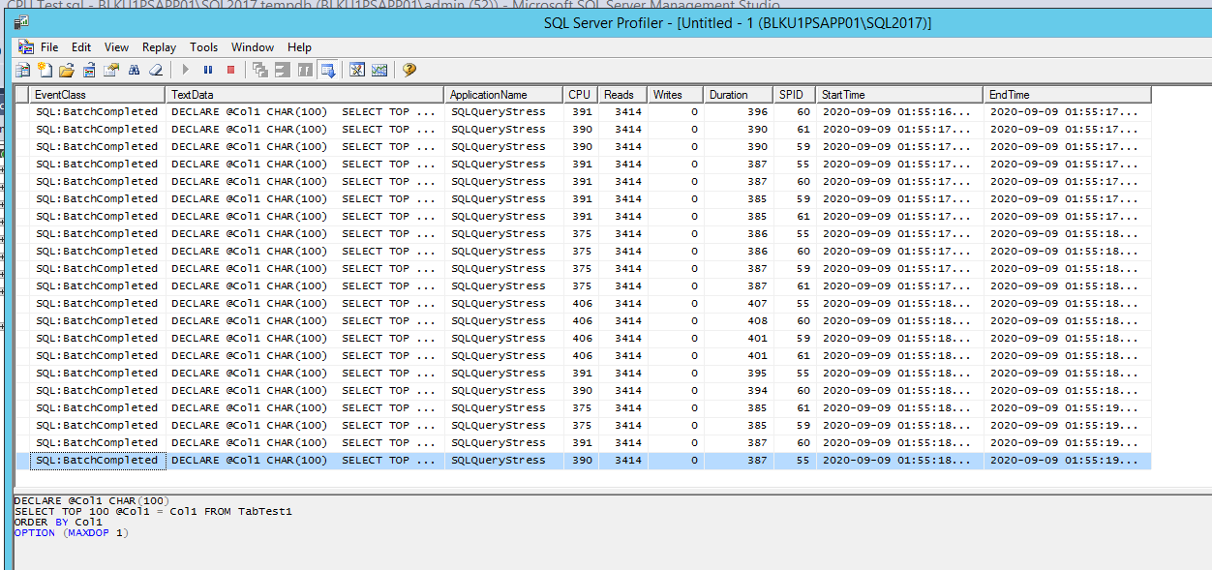

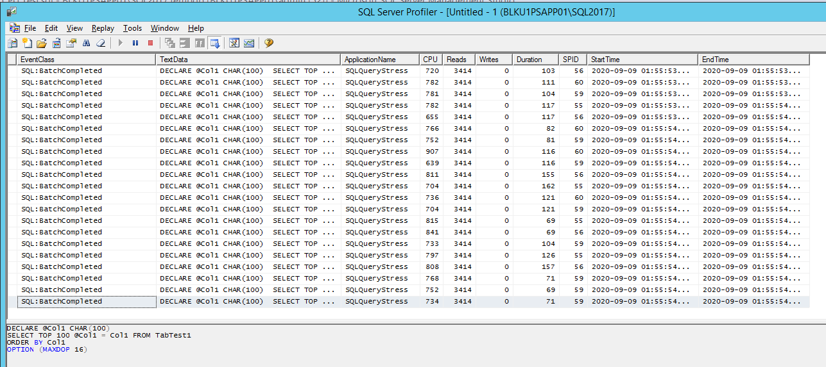

Perfmon counters

